## TAEYOUN kIM

DR. LEHR

CSC-5

December 9, 2013

## Project 2

Monopoly: World Tour

How to change screen size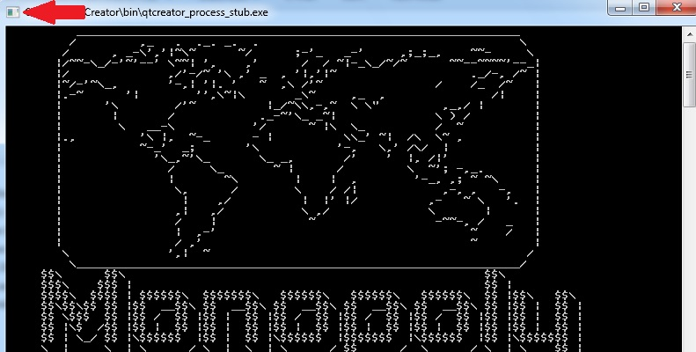

Click left button on here then open Properties

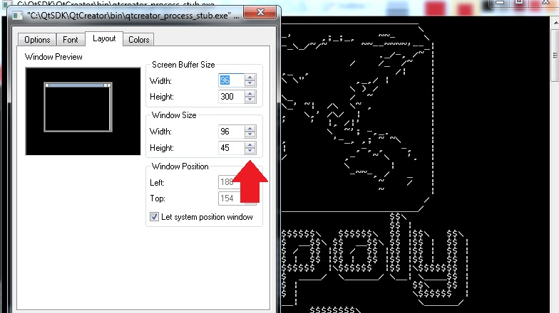

On the Layout tap, change window size as

Width:96

Height:45